**Group 7** Carlos Guttormsen

Miska Örmälä

Yuan Qi

**Inception Phase Report**

This is group seven’s inception phase report for the Introduction to Industrial Informatics course work. In this phase we describe our project’s system vision and define the project environment. We also present our initial work breakdown structure and the project’s cost/benefit analysis.

**System Vision**

In this project, we are going to develop monitoring and supervisory control system of the whole production line n Tampere University of Technology, FAST-Lab. In the process of monitoring the work cell we limit our system vision to a work cell in the floor firstly and then extend to the whole production line which should be managed for following months in the inception phase of our project. First, the planning of project should be divided into several parts which could help us to have more clear idea about what we are going to do. In this system vision, there are four sub-branches: project management, business analysis, environment and requirement and design as well.

In the project management, we should know the objectives of the projects and make some assumptions and assign group-members for different sub-tasks. The schedule should be carried out precisely to finish the project on time. This is the initial part but also the most important part in this project as it is the vision of where we should go.

For the business analysis, we need to evaluate costs for initializing the project such as the costs for the equipment, salary for the operator and manager, maintenance for robots and conveyor, and profits for the shareholders. We must consider some issues like our possible costs, limited budget maybe and prospective profits. As the business model is interwoven with requirements, defining a good business model can cover all our needs and requirements of the project.

For the environment model, we should execute our project in a work cell of TUT and configuration of work-cell must be well organized to ensure the assembly line running efficiently. The interface of human and machines should be well designed which is helpful when we are controlling the whole system and show the information of the customers

When designing the system which is an iterative task, we create the process outline that shows the feasibility of the project. Of course, we also need to consider the potential risks as well. The principle of design is to make full use of each object and reach our goal best and try to lower the risk. The main costs may come from those aspects such as wage for the crew and waste of scrap and maintenance. Therefore, our priority is to control the budget and fully use our material which lowering our costs.

To better initialize our project, the first thing we should do is that we must get familiar with the surrounding of work-cell and avoid causing some unnecessary mistakes or maybe don’t break any equipment in case of increasing our costs. What’s more, we must know the instructions of some machines like Robots and conveyor and so on. For instance, we need to calibrate the workstation before we do the project. Our target is to master in the manipulation of all machinery and reduce the lifecycle of product.

In creating the system vision, we should focus on the assembly line and the main components of this system such as robot, convey and RTUs. The line consists of two conveyors; main and bypass. The main conveyor is used if the pallet requires service from the work cell. Meanwhile, the bypass is used if the work cell is in busy state to bypass the pallet to the next work cell. The factory line uses SONY SCARA robots for production. Each robot is represented as an RTU in the line. The robots are programed with specific tasks. The FASTory is equipped with INICO S1000 Remote Terminal Units (RTUs). INICO S1000 is a programmable RTU device which offers process control capabilities and all the data will be selected and transferred to here for final analysis and decision.

When running the assemble line in reality, the suitable components need to be found respectively. For instance, when we are running the conveyor, which speed is the best for transport of pallet and would not cause congestion on the line. The type and shape of the pallet is maximally flexible for all three products. Those doubts and question must be unveiled when executing the system and get the helpful data for project.

Providing all this architecture (SOA) is impossible without implementing a decent infrastructure for optimization, positioning using sensors and safety switches, resources for maintenance and staff for controlling the whole process (including quality control of the product going out from the manufacturing cell).

To fulfill the task of monitoring we should collect all the data and decide what data to use for monitoring the work cell. For instance, we use INICO S1000 to communicate through web services. It transfers all the data to a web server which can be accessed and processed on the WebStorm, so the needed information is derived for monitoring the work cell. In our case we assume that the user has access to the web site for monitoring is the manager and s/he decides upon receiving the data. Also, we assume the product we mean to monitor in our working cell is a frame of a cell phone that comes in 3 different types of models. We need to closely monitor and assign operators for accomplishing this goal.

**Project Environment**

In the FASTory system there can be found use cases for managers, providers, maintenance operators and quality control operators. The use case list is shown in the picture 1 below.

|  |  |
| --- | --- |
| **Actor** | **Role Description** |
| Manager | Programs and controls the system and RTUs |
| Provider | Loads and unloads the pallet |
| Maintenance operator | Takes care of the conveyors, robots and other components |
| Quality Control Operator | Takes care of the final product quality |

**Picture 1.** Use Case List

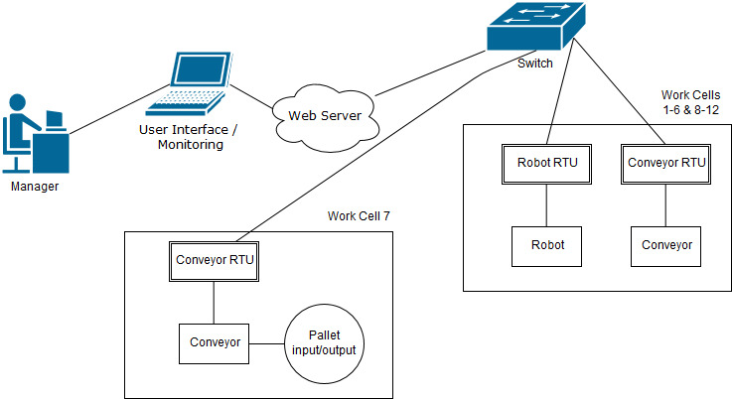The systems architecture consists of a user Interface, a web server, a switch, the INICO S1000 RTUs, conveyors and SCARA robots. The manager can operate the system’s RTUs with the user interface and the webserver according to the system architecture that is illustrated in the picture 2 below.

**Picture 2.** System Architecture

**Plan and Schedule**

The work breakdown structure (WBS) for our project was done using the “ProjectLibre” software. In the picture 3 located below is the WBS for the inception phase of the course project, which was named “KDMOS project”. The tasks for this phase were divided into five different categories: business need, define system and project scope, project environment, plan and schedule, risk and feasibility. Different resources were then assigned to complete the work in these entireties.

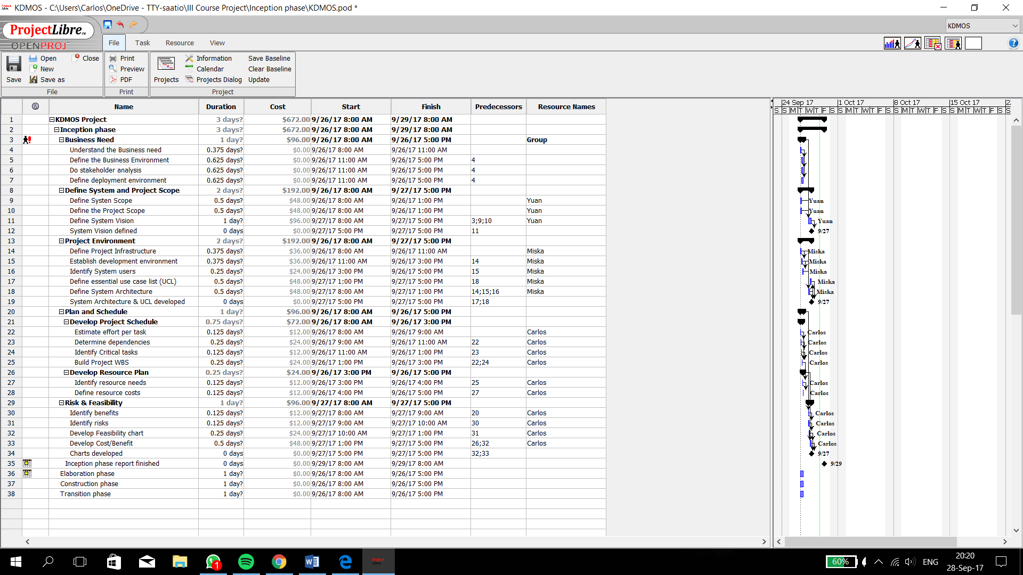

**Picture 3.** Inception phase work breakdown structure

There are four different resources in this project. These include the group members but also a resource called group, which consists of every project member. To give us a rough idea of the labor costs in the inception phase, we set salary values to each project resources. The given salary per hour multiplied by the work hours then gave us the costs for each task. These costs can be seen on the cost column.

**Risk and Cost/Benefit analysis**

To understand the possible project related risks the following risk analysis chart presented in the picture 4 was put together.

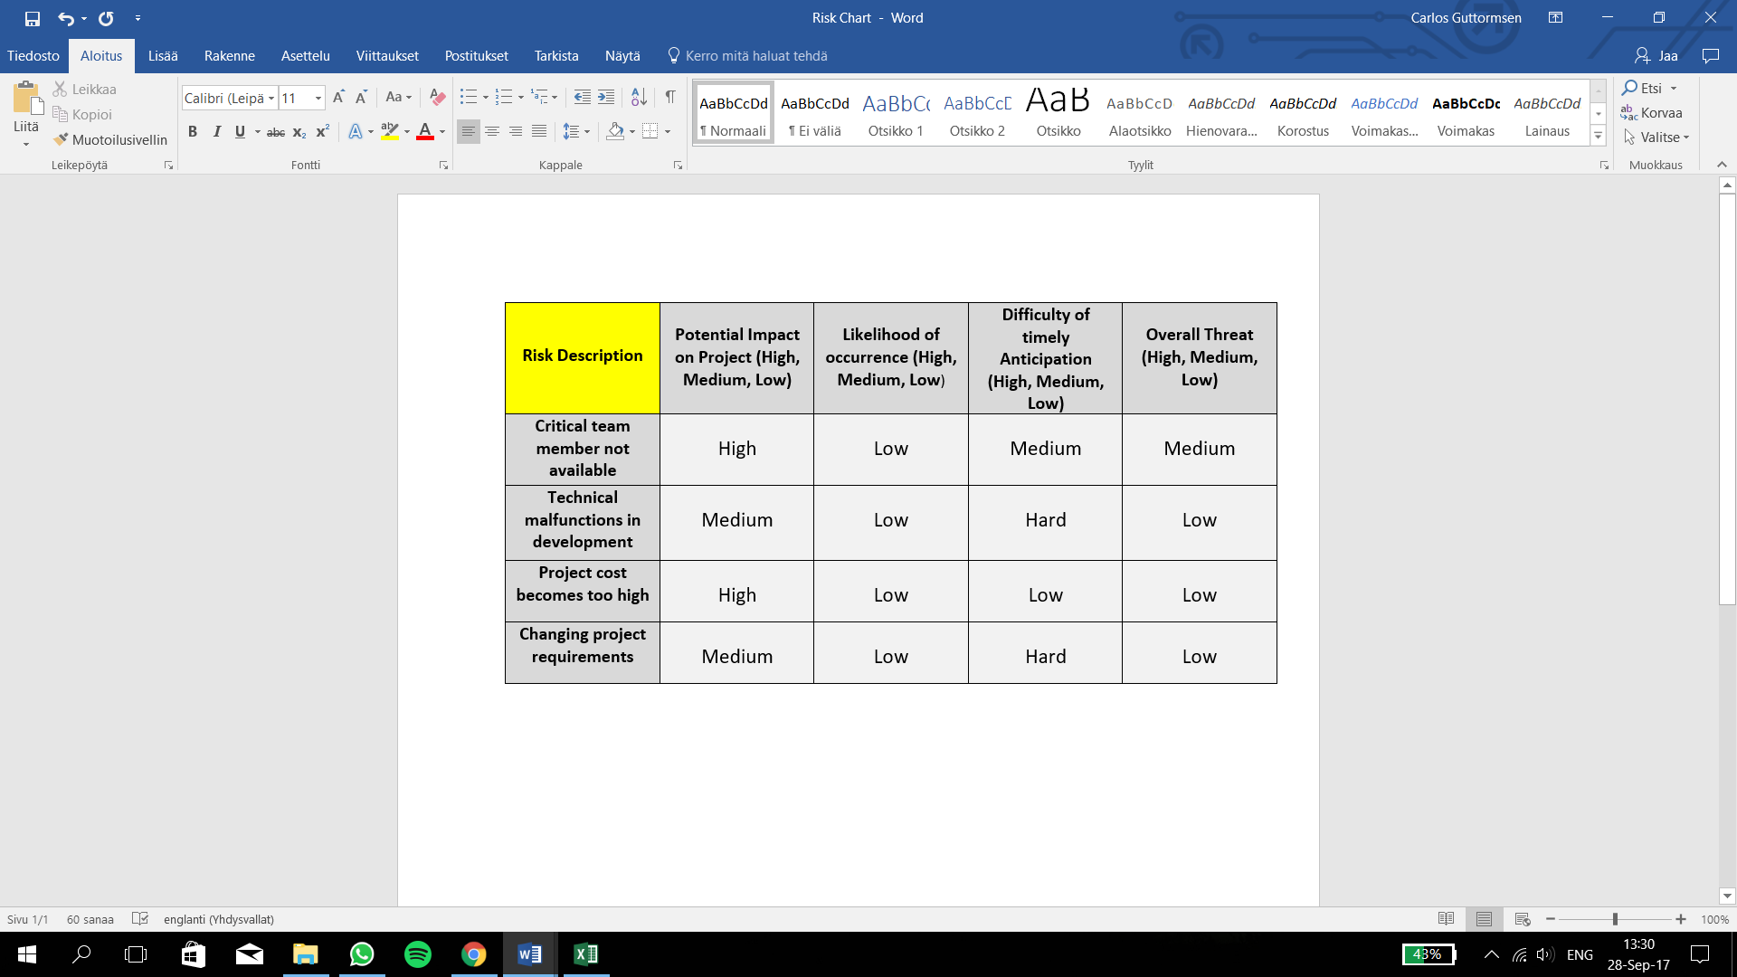

**Picture 4.** Risk analysis chart

In this picture the possible risks were identified and their overall threat to the project were analyzed. This was done by measuring the risk’s potential impact on the project, likelihood of occurrence and difficulty of timely anticipation. All these factors were measured on a scale of low to high.

Lastly, we defined the project’s costs and benefits and put together a cost/benefit analysis chart. This is illustrated in the following picture 5.

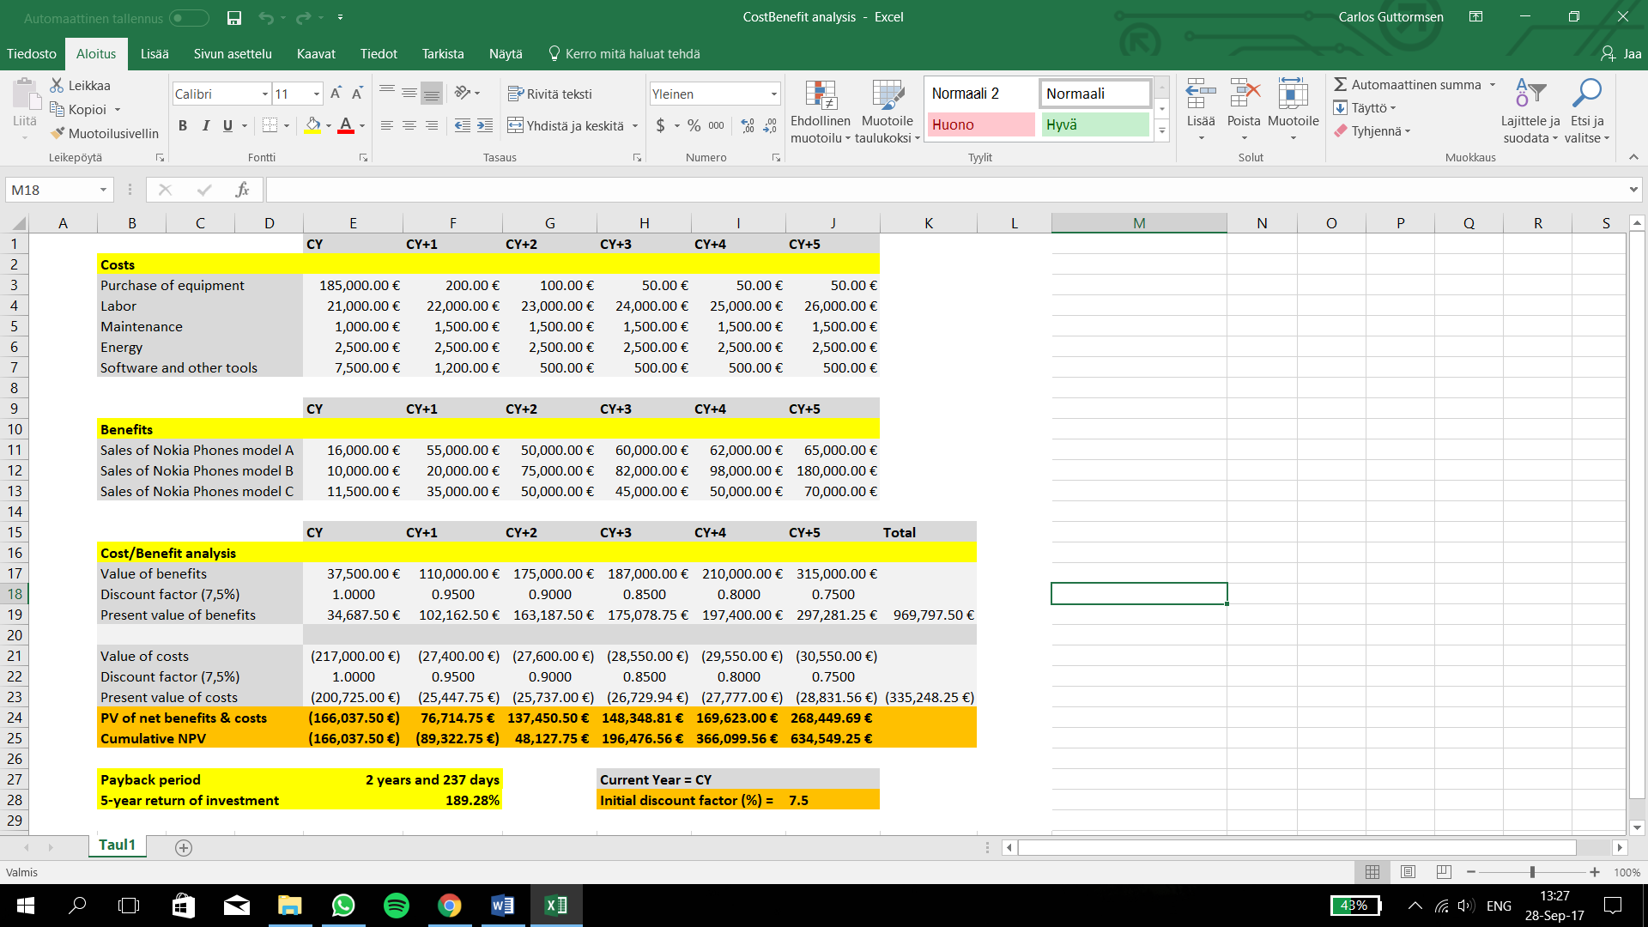

**Picture 5.** Cost/Benefit analysis chart

To make the cost/benefit analysis clearer it was done in three parts. First the different costs were listed and this was followed by listing the different benefits. Finally, the sums of both the costs and the benefits were listed in the third chart. The present values for these sums were calculated using a dynamic discount factor which initially was set to 7,5%. Using the cumulative net profit values, we could calculate the payback period which came out to be two years and 237 days. The five-year return of investment was calculated by dividing the final NPV with the total costs and it turned out to be 189,28%.